# CS 255 System Design Document Template

This template lays out all the different sections that you need to complete for Project Two. Each section has guidance to prompt your thinking. You will need to continually reference the interview transcript as you work to make sure that you are addressing your client’s needs. There is no required length for the final document. Instead the goal is to complete each section based on what your client’s needs are. Remove this note when you are finished, and replace all bracketed text with the relevant information.

## UML Diagrams

### UML Use Case Diagram

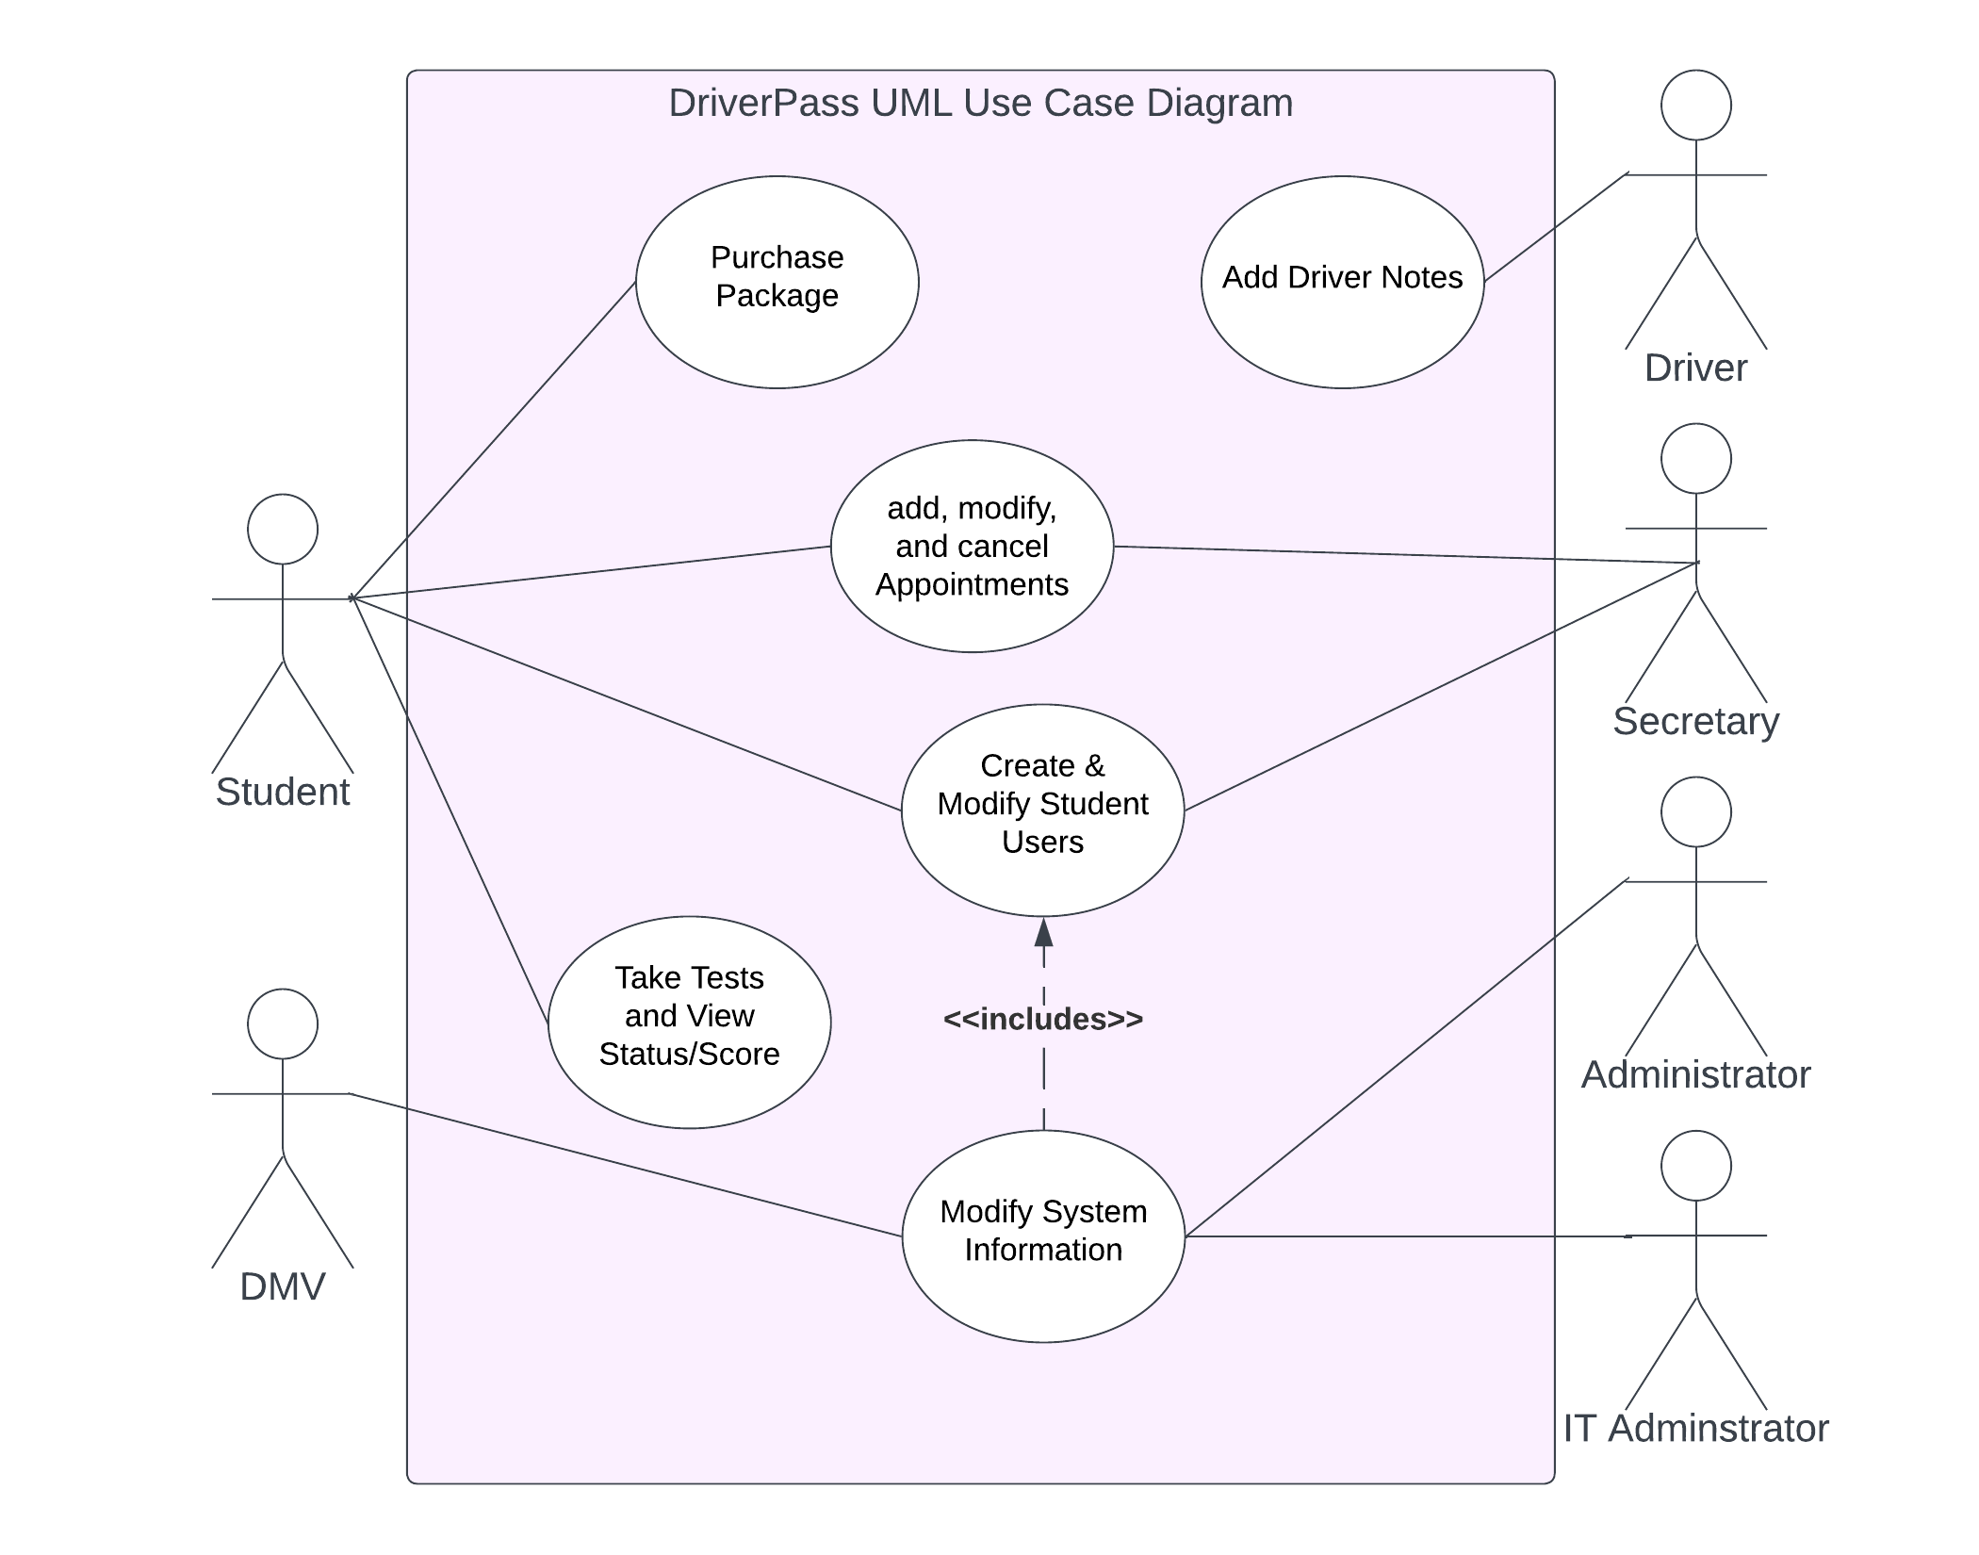

Figure : UML Use case diagram for DriverPass system

### UML Activity Diagrams

1. Activity Diagram for Add Appointment use case

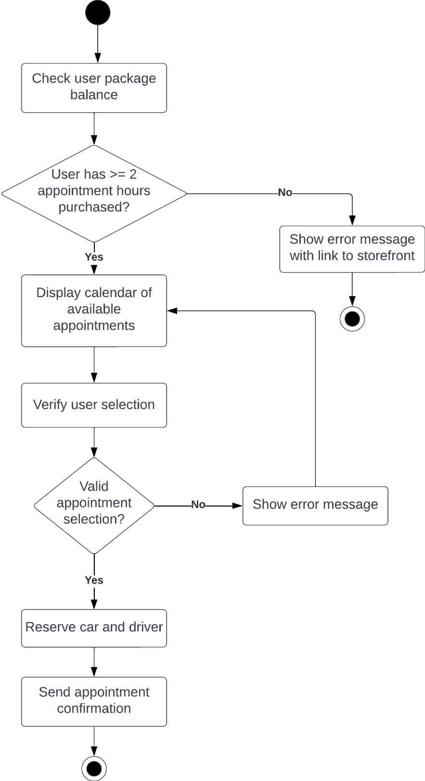

Figure : UML activity diagram for DriverPass schedule appointment use case

1. Activity diagram for Create Student User use case

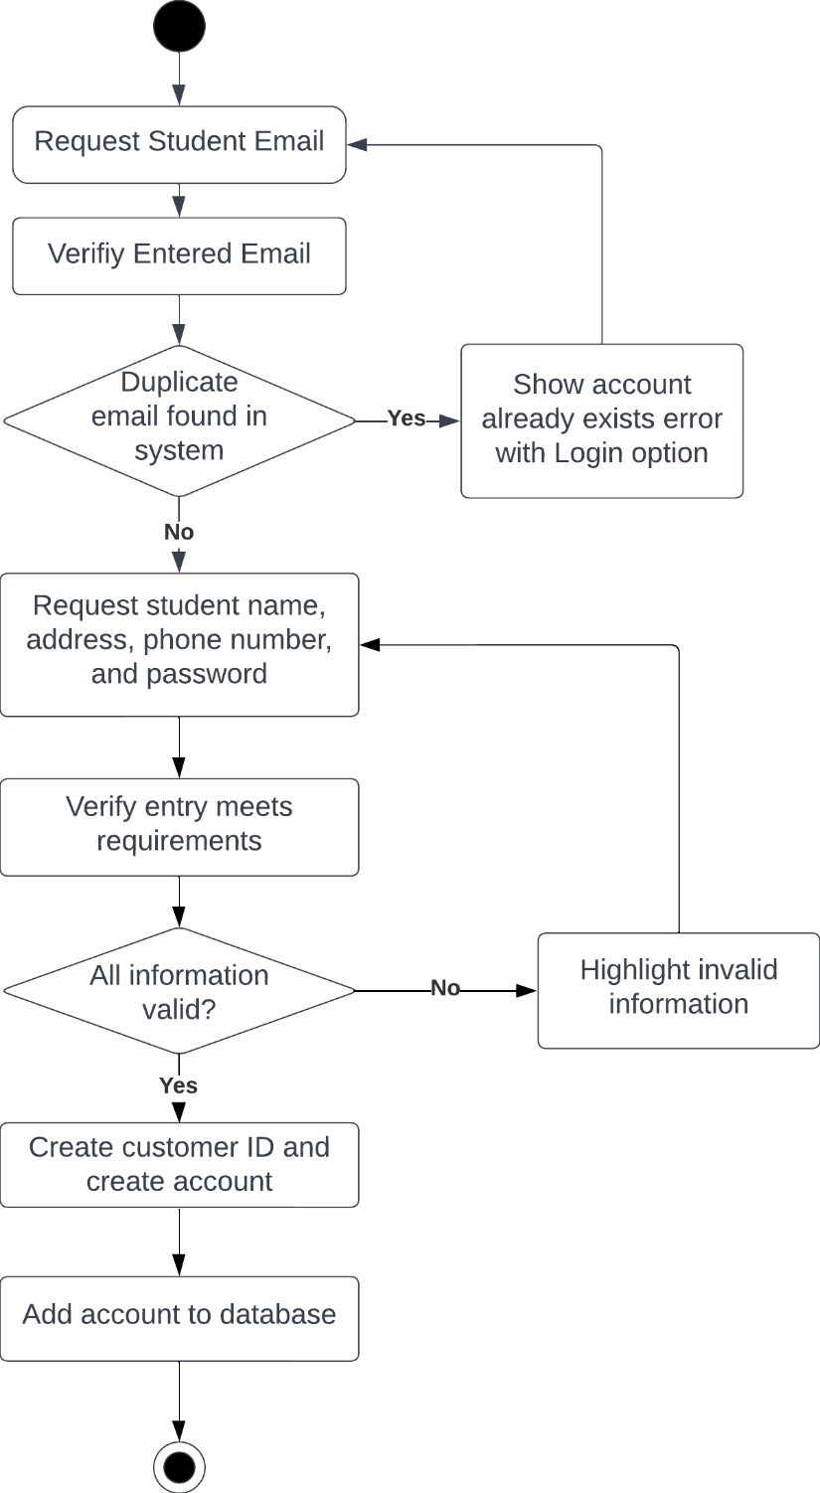

Figure : UML activity diagram for create account use case

### UML Sequence Diagram

Sequence diagram for Create Student User use case

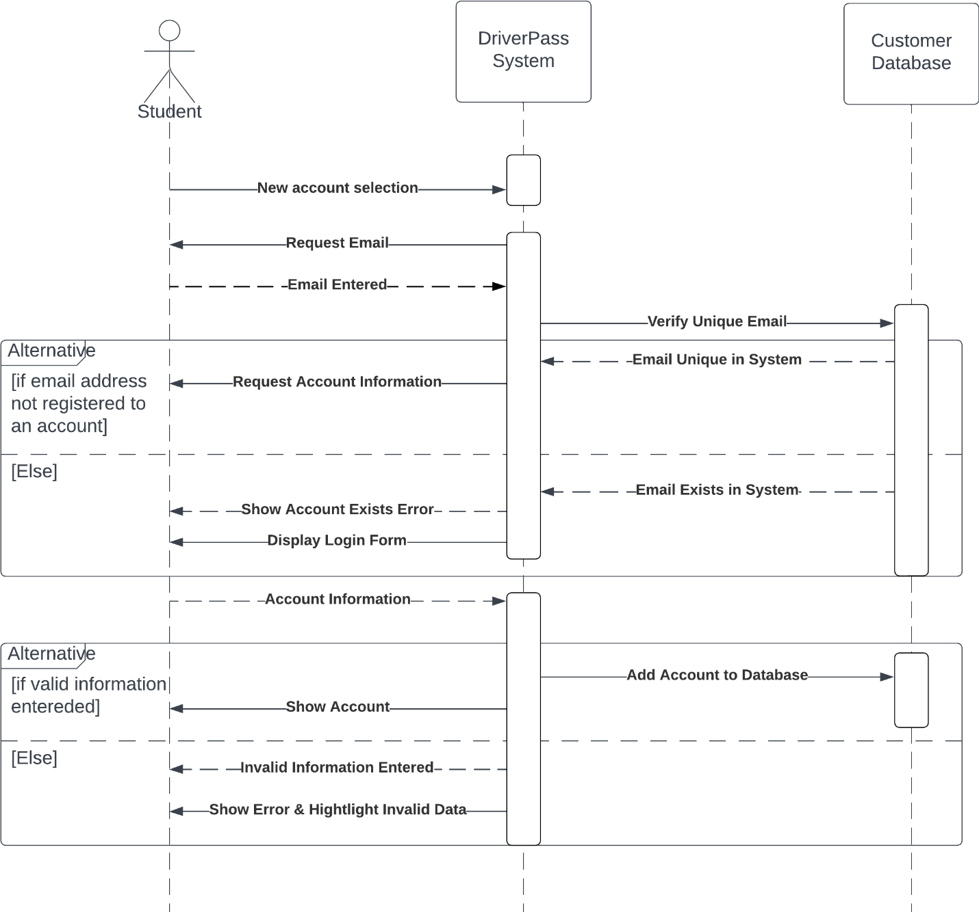

Figure : UML sequence diagram for create account use case

### UML Class Diagram

Figure : UML class diagram for DriverPass system

## Technical Requirements

*[Based on the diagrams you have created, describe the technical requirements of your system. These requirements should address the required hardware, software, tools, and infrastructure necessary for your system design.]*

Required Hardware:

* Linux server for hosting cloud services
* RAM, hard drive, and processor sized according to projected server activity and database size.
* Three sets of the following (for secretary, IT administrator, and administrator):
  + PC
  + Keyboard
  + Mouse
  + Monitor(s)
* Phone system for secretary

Required Software:

* Windows OS for each employee PC
* Secure socket layer
* Ecommerce software
* Payment processing software
* Antivirus software for server and PCs

Tools and Infrastructure:

* Office or other secure location(s) for all hardware
* Cars available for each driver